**Lab 9**

* **Create the Enhanced Relationship Diagram using the Reverse Engineer functionality in MySQL Workbench.**

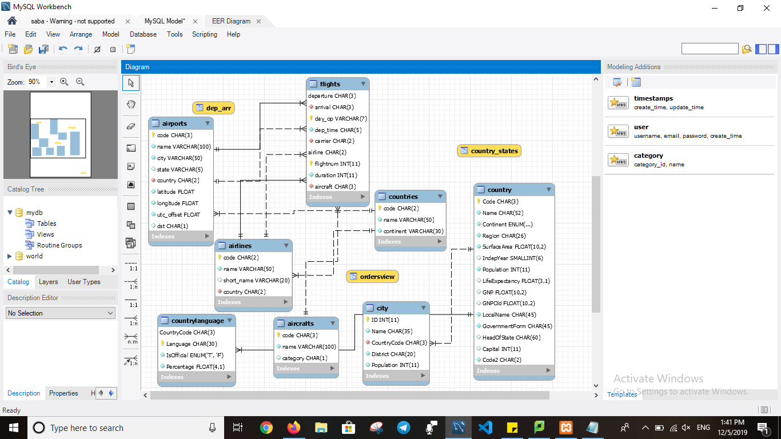

* **Inspect the tables and suggest which columns would be good candidates for indexes being applied to them and why**

**Indexes** are used to retrieve data from the database more quickly than otherwise. The users cannot see the **indexes**; they are just used to speed up searches/queries. Note: Updating a **table** with **indexes** takes more time than updating a **table** without (because the **indexes** also **need** an update).

And I suggest to do with flights table and airport because they are used to much so it is better to put indexes for these table and in flights table for flight number and dep-time and airline. Also, in airport table we can put indexes for name, country.

* **Inspect the tables and suggest which columns would NOT be good candidates for indexes being applied to them.**

In flights and airport table are exist many columns but some of them not used much. So, some of them are day-op, duration and short name in airport table.

* **Apply the indexes to the database.**

select *from flights;

create index fightnum_index on flights(flightnum);

select *from flights;

create index airline_index on flights(airline);

